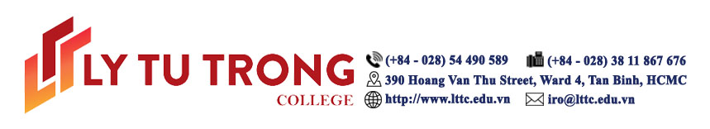
Ho Chi Minh City, November 28th 2019

Dear Mr. Joseph Goh,
Vice President, Solutions,

We are pleased to invite you to the Conference on Smart Schools 2019 (COSS2019) with the theme “Smart School Governance in the context of the Fourth Industrial Revolution”, on December 14th, 2019 at the Ly Tu Trong College campus in Ho Chi Minh City, Vietnam.
Partnering with Ly Tu Trong College in organizing the conference are Arizona State University (USA), Vietnam Finland International School, Schneider Electric Corporation (France), KONE Corporation (Finland), Chosun University (Korea) and other higher education institutions in Vietnam.
The conference also will include guests of honor from the Directorate of Vocational Education and Training, Department of Labour - Invalids and Social Affairs, and the Department of Education and Training in Ho Chi Minh City.
The conference objectives are:
-To serve as a global platform of intellectual exchange to encourage scholars, academicians and researchers to present research regarding smart schools in the context of the Fourth Industrial Revolution;
-To update participants on trends and practices in smart schools emerging within the Fourth Industrial Revolution movement, and preparing higher education professionals to face challenges and seize opportunities in the movement;
-To dropose and discuss the development of quality innovations for smart schools to advance Technical and Vocational Education and Training (TVET) in Vietnam and strengthen Vietnam’s readiness to develop smart industry in the Fourth Industrial Revolution;
-To provide participants, visitors, enterprises and students with the opportunity to update their knowledge of TVET smart technologies hands-on practices;
-To establish networks and functional partnerships among Vietnamese and international education institutions, governmental and non-governmental organizations, business and advocacy groups for the development of smart institutions.
It is our honor to invite you as a Keynote Speaker. Your work in smart school development has left a great imprint in the education field and we would like to spotlight on your achievements. We will soon contact you to discuss this opportunity for collaboration. Should you have any questions about the event, please contact us at nguyenngoctrang@lttc.edu.vn

Sincerely yours,

Meritorious Teacher Pham Huu Loc
Rector Ly Tu Trong College, HCMC

Appendix

This call for submission of papers and poster presentations for the COSS2019 Conference includes study findings and papers on the following sub-themes:
- Opportunities and challenges in shifting education paradigms, teaching and research 4.0, and developing smart institutions;
- Practical information technology applications in smart school management in the Fourth Industrial Revolution context;
- Smart school Governance: Development and management in the Fourth Industrial Revolution;
- Innovations for high quality teaching and learning in smart schools;
- Development of Learner Think Tank strategies in smart colleges;
- Linkages and connections between enterprises, schools and students in smart schools to develop human resources for the Fourth Industrial Revolution.
Important Dates
Paper submission November 30th, 2019
COSS2019 Conference December 14th, 2019

The COSS2019 proceedings will be published by the National Institute for Vocational Training Education.



